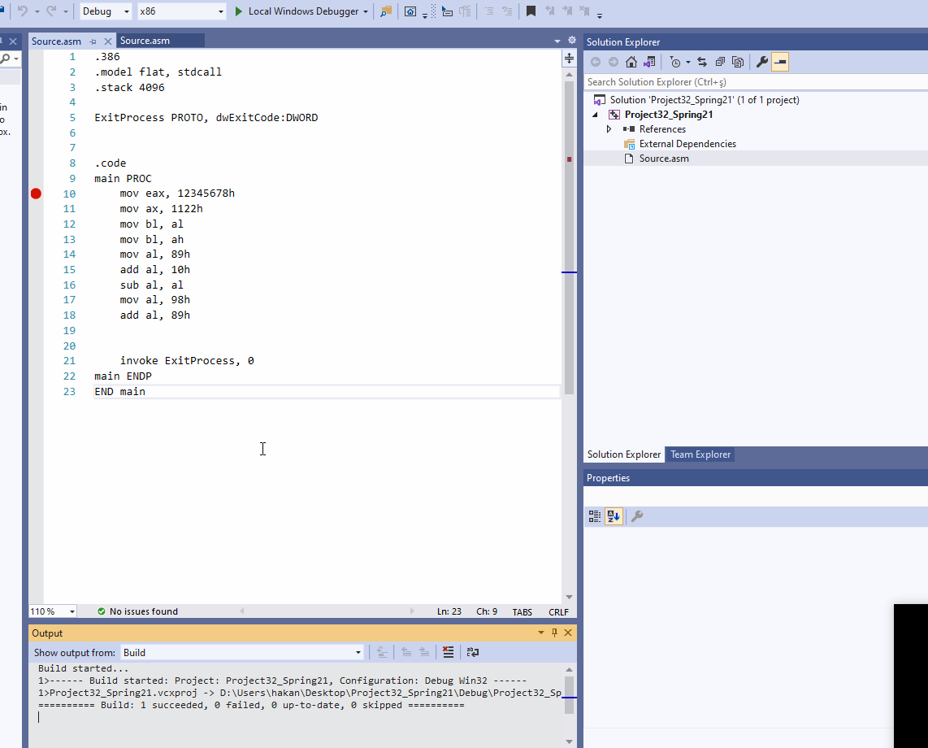

CSC 3210

Computer Organization and Programming

Lab 3 (b)

Answer Sheet

Student Name: Hakan Gunerli

Section:

Debug through each line of code and explain the register content and flags.

(We already answered line 10 to 13 for your reference. Start writing your answer from Line 14)

Line: 10

Instruction: mov eax, 12345678h

Register value: EAX = 12345678

Explanation: 12345678 is a hexadecimal value which is 32-bit in binary. EAX register is also 32-bit.

Line 11:

Instruction: mov ax, 1122h

Register value: EAX = 12341122h

Explanation: 1122 is hexadecimal and it is 16-bit in binary. this mov instruction only updates AX (16 bit) register, a part of EAX register. That’s why you can see that the upper portion of EAX register is NOT updated.

Line 12:

Instruction: mov bl, al

Register value: EBX = 00765022

Explanation: AL register is 8-bit long. When you mov the content of al register (22) to BL register, it only updates the first 8-bit of the EBX register. The rest contains the garbage value.

Line 13:

Instruction: mov bl, ah

Register value: EBX = 00765011

Explanation: Ah register is 8-bit long. When you mov the content of AH register (11) to BL register, it only updates the first 8-bit of the EBX register. The rest contains the garbage value.

Line 14:

Instruction: mov al, 89h

EAX: **12341189**

Explain the content of the EAX register.

**The last two numbers within the EAX register are changed from 11 to 89.**

Line 15:

Instruction: add al, 10h

What Register value of EAX, after executing line 15? 12341199

Do you see any change in flags?

Show the step of the hexadecimal addition.

**The value represents a positive sign.(PL = positive sign flag)**

OV = 0 UP = 0 EI = 1 PL = 1 ZR = 0 AC = 0 PE = 1 CY = 0

123411189

000000010

=**12341199h**

Line 16:

Instruction: sub al, al

What Register value of EAX, after executing line 16? 12341100

Do you see any change in flags?

Show the step of the hexadecimal subtraction.

**The values were subtracted, thus the value ended with a 00**

OV = 0 UP = 0 EI = 1 PL = 0 ZR = 1 AC = 0 PE = 1 CY = 0

**12341199**

**00000099**



**=12341100**

Line 17, 18:

Instruction:

mov al, 98h

add al, 89h

What Register value of EAX, after executing line 17 and 18?

Do you see any change in flags? **OVERFLOW, CARRY HAVE CHANGED.**

After line 17, 12341198 Moved 98 to hexadecimal.

After line 18, 12341121 ended up with 21.

OV = 1 UP = 0 EI = 1 PL = 0 ZR = 0 AC = 1 PE = 1 CY = 1

1. Suppose a program contains 500 million instructions to execute on a processor running on 2.2 GHz. Half of the instructions takes 3 clock cycles to execute, where rest of the instructions take 10 clock cycle. What is the execution time of the program?



1. A processor is 20 MIPS. If you run a program on that processor and the program takes 30 seconds to finish. How many instructions are there in this program?

